|  |  |
| --- | --- |
|  | **Harrisdale Senior High School**  **Science Department** |

**ATAR Physics Units 1 and 2**

**Task 6: Electricity Investigation 2022**

|  |  |
| --- | --- |
| **Student name:** |  |
| **Teacher name:** |  |
| **Date:** |  |

**Background**

When constructing circuits, electrical engineers need to know the characteristics of the components being used. Some of this information can be provided in the form of a graph that shows the current that will flow through a component at different voltages. Two examples of these graphs, which are usually called IV (current-voltage) curves, can be seen below.

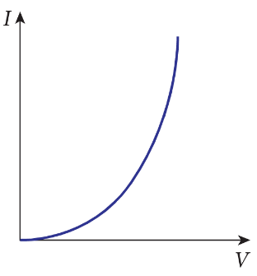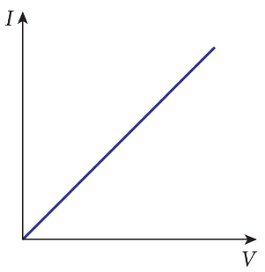

Electrical components can be described as ohmic or non-ohmic. Ohmic components provide a constant resistance, giving a linear IV curve (e.g. the right example above). The gradient of the line in this graph is constant. If you apply a higher voltage, more current will flow through the component in proportion to its resistance according to Ohm’s law: $I=\frac{V}{R}$.

Non-ohmic components, predictably, are those where the gradient of the line (and therefore the resistance) is not constant, giving a non-linear IV curve such as in the left example. Applying a higher voltage across these components still results in a higher current flow, but the relationship is not directly proportional – Ohm’s law does not apply.

**Aim**

In this assessed investigation, you will be given two different components and determine whether they are ohmic or non-ohmic devices.

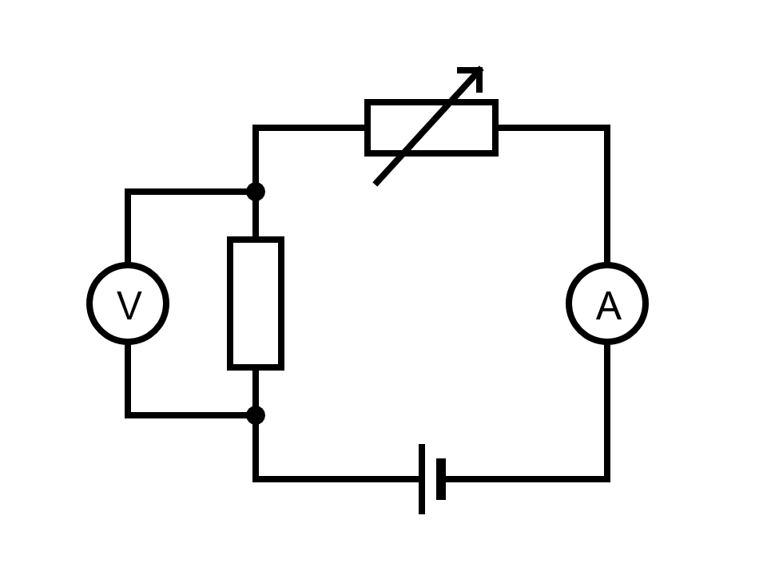**Materials**

* 20 Ω resistor
* Globe
* Variable resistor
* Power supply
* Ammeter
* Voltmeter
* At least six wires

**Method**

1. Collect all equipment.
2. Construct a circuit that connects the 20 Ω resistor in series with the variable resistor and the power supply. The ammeter and voltmeter should be placed so they can measure the current passing through the lamp and the voltage drop across it (see circuit diagram).
3. Set the variable resistor to have minimum current and measure the voltage and current flow.
4. Change the value of the variable resistor, recording the current and voltage each time it is changed. You should make at least six readings.
5. Replace the 20 Ω resistor with the globe and repeat steps 3 and 4.

**Analysis and Discussion**

1. Draw a table containing the data that you obtained for this experiment.
2. Using the same axes for both sets of data (i.e. one graph with the data from both components on it), construct IV curves for the 20 Ω resistor and the lamp.

|  |  |  |  |  |  |  |  |  |  |  |  |  |  |  |  |  |
| --- | --- | --- | --- | --- | --- | --- | --- | --- | --- | --- | --- | --- | --- | --- | --- | --- |
|  |  |  |  |  |  |  |  |  |  |  |  |  |  |  |  |  |
|  |  |  |  |  |  |  |  |  |  |  |  |  |  |  |  |  |
|  |  |  |  |  |  |  |  |  |  |  |  |  |  |  |  |  |
|  |  |  |  |  |  |  |  |  |  |  |  |  |  |  |  |  |
|  |  |  |  |  |  |  |  |  |  |  |  |  |  |  |  |  |
|  |  |  |  |  |  |  |  |  |  |  |  |  |  |  |  |  |
|  |  |  |  |  |  |  |  |  |  |  |  |  |  |  |  |  |
|  |  |  |  |  |  |  |  |  |  |  |  |  |  |  |  |  |
|  |  |  |  |  |  |  |  |  |  |  |  |  |  |  |  |  |
|  |  |  |  |  |  |  |  |  |  |  |  |  |  |  |  |  |
|  |  |  |  |  |  |  |  |  |  |  |  |  |  |  |  |  |
|  |  |  |  |  |  |  |  |  |  |  |  |  |  |  |  |  |
|  |  |  |  |  |  |  |  |  |  |  |  |  |  |  |  |  |
|  |  |  |  |  |  |  |  |  |  |  |  |  |  |  |  |  |

1. Which of the two components is ohmic, and which is non-ohmic? Use your graph to explain your choice.

|  |
| --- |
|  |
|  |
|  |
|  |
|  |
|  |

1. Use your knowledge of resistance in metals to explain the shape of the IV curve for the non-ohmic device.

|  |
| --- |
|  |
|  |
|  |
|  |
|  |
|  |

1. Calculate the gradient (slope) of the linear IV curve. What does this tell you about the component with this curve?

**Validation**

You must hand in this booklet on Thursday 26 May. A validation test for this investigation will be given in class on the same day.